Laboratory Report - TMM4205 - Tribology and Surface Technology

*Written by Håvard Wilson, Department of Production and Quality Engineering, Subsea Technology and Peter Skjerstad, Department of Materials Science and Engineering, Materials Technology.*

*All data used in this report is from the data collected by group 2.*

Trondheim, XX.04.13

_______________________ ________________________

Håvard Wilson Peter Skjerstad

# Theory

## Corrosion

Corrosion in an electrochemical reaction. This electrochemical reaction occurs when a metal or an alloy comes into contact with an aqueous solution. During this reaction the metal dissolves and ends up as ions in the surrounding solution. Corrosion is therefore commonly referred to as an chemical attack on the material.

During corrosion two reactions happens: the cathodic reaction, and the anodic reaction

The anodic reaction for iron can be:

* Fe(s) -> Fe2+ + 2e-

The cathodic reaction can be:

* 1/2O2 + H2O + 2e- -> 2OH-

or

* 2H+ + 2e- -> H2(g)

The iron ions are conducted towards the OH- ions, and together they form a metal hydroxide that may either form a solution or be deposited on the metal surface. During the reaction between iron and hydroxide there is multiple oxidation states occurring. Fe(OH)2 is not stable, and if oxygen and water is present it will react to form trivalent hydrated iron oxide Fe2O3∙nH2O, iron hydroxide Fe(OH)3 or FeOOH + H2O, where FeOOH is the common red rust.

The oxide layer that forms on the iron surface is both brittle and porous, and thus will not protect the iron substrate to any mentionable degree. For other metals such as aluminium the oxide layer can form a dense and robust oxide layer that protects the aluminium substrate from further reaction to the environment. This is why aluminium have excellent resistance to general corrosion in most environments and iron does not.

Polarization curves

Polarization curves can be made to estimate a variety of corrosion properties for different materials. It can be used to estimate the materials passivation properties, to estimate the corrosion rate in galvanic couplings as well as corrosion rates in the transpassive region (pitting corrosion).

Polarization curves are recorded by applying a change in potential using the potentiostat and measuring the current (or in this case the voltage over a known resistance and applying ohm’s law to get the current)

First the cathodic curve is plotted (to avoid corrosion to the work electrode), then the current is set back to OCP before the anodic curve is plotted.

Linearized Polarization Resistance (LPR)

Another way this can be done is by checking the corrosion rate in the general corrosion area, and this is called linearized polarization resistance. In a limited potential range (± 20 mV) around the corrosion potential, the relationship between the potential and the external current is approximately linear. As a result the Stern-Geary’s equation (equation 1) can be applied.

*(1)*

Equation 1 can be rewritten as

*(2)*

ba and bc are the anodic and cathodic Tafel equations. For this exercise ba=59 mV and bc =118 mV. The advantage of this method is that the test setup does not disrupt the natural corrosion rate to any mentionable degree.

Calculation of corrosion rate

The corrosion current density (equation 3) is commonly used to calculate the corrosion rate.

*(3)*

The relationship between material loss divided by areal and time, and the corrosion current density is determined from Faraday’s as shown in equation 4.

*(4)*

To get the results from formula 4 in mm/year it can be written as:

(5)

## Tribology

*Brieﬂy describe hydrodynamic lubrication and explain what causes the friction force in the hydrodynamic regime.*

*.*

(6)

ρ * v (7)

(8)

(9)

(10)

(11)

(12)

For this experiment it is assumed that the elasticity module and Poisson’s ration is the same for both the ball and the plate, and are 210 GPa and 0,3 respectively, this simplifies equation 12 and we get:

(13)

## Tribocorrosion

*Very brieﬂy explain the principles of corrosion, wear and tribocorrosion. Mention which materials are espescially vulnerable to the combined action of wear and corrosion. Explain Potentiostatic Wear*

# Experimental Procedure

## Linearized Polarization Resistance

The equipment and chemicals needed to conduct this experiment is listed in table 2.1.

Table **Error! Use the Home tab to apply 0 to the text that you want to appear here.**‑1 Equipment and chemicals

|  |
| --- |
| 2x Voltmeters |
| 1x Potensiostat |
| 1x Beaker |
| 1x Caliper |
| 1x Work Electrode – Carbon Steel |
| 1x Conter Electrode – Platinum |
| 1x Reference Electrode – Calomel Electrode |
| 1x Resistor |
| Cables |
| Electrolyte – 3.5wt% NaCl Solution |

The experiment assemble is shown in figure 2.1-1 and 2.1-2. All the electrodes are places within the same electrolyte. The Reference electrode was connected to the Reference-connection on the Potensiostat and the Counter electrode was connected to the C-connection, through the resistor, which means a 10Ω resistance was placed in the system. Over the resistor a Voltmeter, hereby called Voltmeter 2, was connected, and the voltage fall recorded over this 10Ω resistance gives the current of the system. The Work electrode was connected WE-connection on the Potensiostat with a Voltmeter, hereby called Voltmeter 1, connected to measure the Voltage in the system.

The Work Electrode (The test specimen) was a small carbon steel plate with electrical contacts underneath the beaker.

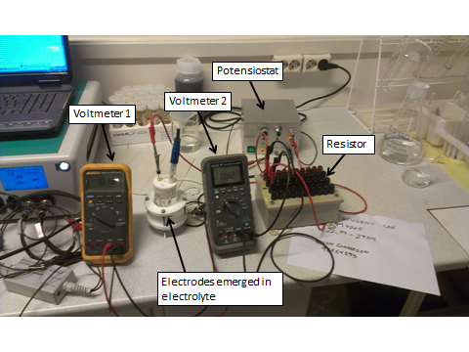

Figure **Error! Use the Home tab to apply 0 to the text that you want to appear here.**‑1 Overview over the Experimental Assembly

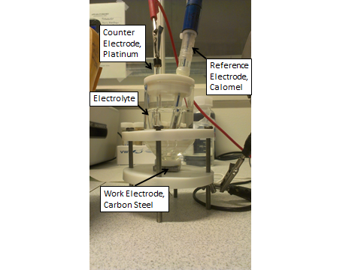After the setup was complete the Open Circuit Potential (OCP) was measured. This was done by not applying any current to the system with the potensiostat. After waiting several minutes for the system to stabilize, the OCP was found by using Voltmeter 1.

Figure **Error! Use the Home tab to apply 0 to the text that you want to appear here.**‑2

After finding the OCP the potensiostat was used to polarize the Work Electrode 10mV in cathodic direction, and after about 3 minutes the current was found by using Voltmeter 2. Then the Work electrode was polarized 10mV in anodic direction, about after about 3minutes when the system had stabilized the current was measured.

After the testing was completed the area of the work electrode in contact with the electrolyte was measured.

## Polarization Curves

This experiment uses the same equipment, chemicals and assembly as the Linearized Polarization Resistance experiment.

The OCP was measured again, and then the work electrode was polarized 200mV in cathodic direction with 50mV steps. At each step there was a 3 minute wait for the system to stabilize, before the system was further polarized. At each step the current in the system was measured.

After the cathodic values were recorded, the potensiostat was turned off to let the system return to OCP. When the system had stabilized at OCP, the Work Electrode was polarized 200mV in anodic direction in 50mV steps. At each step the current in the system was measured.

## Stribeck Curves

The equipment and chemicals needed to conduct the Stribeck Curves experiment is given in table 2.3-1.

Table **Error! Use the Home tab to apply 0 to the text that you want to appear here.**‑2 Equipment and chemicals

|  |
| --- |
| 1x CSM – Instrumento Tribometer |
| 1x Hardened Steel Ball |
| Lubrication – Statoil Merete 320 |
| 1x 2N weight |

The test parameters for this experiment are given in table 2.3-2

Table **Error! Use the Home tab to apply 0 to the text that you want to appear here.**‑3 Test Parameters

|  |  |  |
| --- | --- | --- |
| Parameter | Range | Unit |
| Speed | 0,5-12 | cm/s |
| Load | 2 | N |
| Oil Viscosity | 320 | cSt |
| Ball Diameter | 6 | mm |

The hardened steel ball was installed in the Tribometer, and balances, such that no weight from the machinery would affect the measurements. Then the equipment was started. At first the machine rotated the steel plate to determine the resistance in the system, so this wouldn’t affect the measurements. After the resistance in the system was measured the force was applied and contact between the steel ball and steel plate was made. The test was done at 0.5, 1.0, 1.5, 2.0, 3.0, 4.0, 5.0, 6.0, 8.0, 10.0, and 12.0 cm/s, and the friction factor was measured when a stable value had occured. Figure 2.3-1 shows the setup of the experiment.

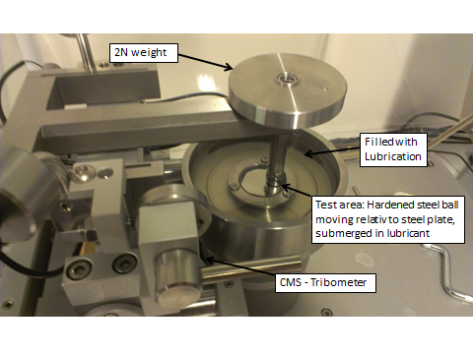

Figure 2.3‑1

## Wear at OCP

All equipment and chemicals need for the Wear at OCP are listed in Table 2.4-1

Table **Error! Use the Home tab to apply 0 to the text that you want to appear here.**‑4 Equipment and chemicals

|  |
| --- |
| 1x TriboCorr machine |
| 1x Alumina Ball |
| 3.5wt% NaCl Solution |
| 1x Super Duplex Stainless Steel Specimen |
| 1x Reference Electrode – Calomel |

All relevant test parameters are listed in Table 2.4-2

Table **Error! Use the Home tab to apply 0 to the text that you want to appear here.**‑5 Paramater for Wear at OCP Test

|  |  |  |
| --- | --- | --- |
| Parameter | Range | Unit |
| Rotation | 60 | rpm |
| Stroke length | 10 | Mm |
| Diameter Ball | 4.67 | mm |
| Sample size | 25 by 25 | Mm |
| Load | 20 | N |
| OCP Duration | 120 | Seconds |
| Nr. Of cycles | 300 | N/A |
| OCP Duration after test | 180 | Seconds |

The assembly of this experiment is shown in figure 2.4-1 and 2.4-2.

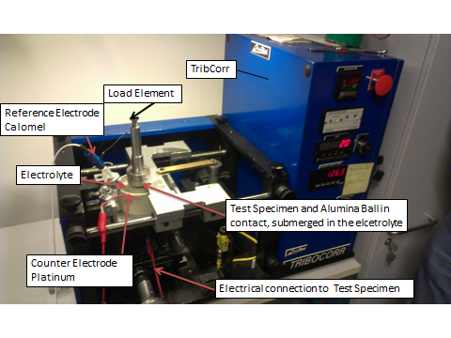

Figure 2.4‑1 TriboCorr machine used in Wear at OCP and Potentiostatic Wear experiements

The test specimen (Super Duplex plate) was placed and fastened in the testing area, and an electrolyte (3.5wt% NaCl Solution) was applied. An abrasive element (Alumina Ball) was mounted atop of the test specimen and a load of 20N was applied using a spring.

The Reference Electrode (Calomel) and Test Specimen was connected to the TripCorr machine, and OCP was measured with the TribCorr. The OCP was measured for 120s to get a stable reading, then the machine started moving the Alumina Ball to apply wear to the test specimen. During 300 cycles of wear the potential of the Super Duplex Stainless Steel was measured. After the wear was complete, the OCP was measured for 180s so a stable OCP could be measured

## Potentiostatic Wear

Table 2.5-1 shows the necessary equipment and chemicals needed to conduct the Potentiostatic Wear experiment. The only difference between this and the OCP experiment is the added Counter Electrode.

Table **Error! Use the Home tab to apply 0 to the text that you want to appear here.**‑6 Equipment and chemicals

|  |
| --- |
| 1x TriboCorr machine |
| 1x Alumina Ball |
| 3.5wt% NaCl Solution |
| 1x Super Duplex Stainless Steel Specimen |
| 1x Counter Electrode – Platinum |
| 1x Reference Electrode |

Table **Error! Use the Home tab to apply 0 to the text that you want to appear here.**‑7

|  |  |  |
| --- | --- | --- |
| Parameter | Range | Unit |
| OCP Duration | 120 | Second |
| Applied potential duration | 180 | Second |
| Nr of cycles | 300 |  |
| OCP Duration after test | 0 | Second |
| Potential applied to Sample | 600 | mV |

The assembly in this experiment is more or less the same as in OCP, the difference is the Counter Electrode that has been added to the electrolyte.

After the OCP has been measured for 120s the sample was polarized to 600mV. After waiting 180s for the system to stabilize, the wearing began and after 300 cycles the test was ended. Potential and current was measured continuously throughout the by the TRIBCORR.

# Results

## Linearized Polarization Resistance

The OCP was found to be -1068mV, relative to a calomel electrode. The diameter of the test area was measured to be D=1,14 cm.

Using formula 1, presented in chapter 1 the corrosion current can be found.

By applying formula 3 the corrosion current density can be calculated

By applying formula 5 the corrosion rate in mm/year can be found

The results from polarizing +/- 10mV from the OPC can be found in table 3.1-1, and is presented in figure 3.1-1.

Table 3.1-1 Linear Polarization Data

|  |  |
| --- | --- |
| Linear  polarization | |
| Potential  (mV) | Current  (mA) |
| -1078 | -0,001 |
| -1058 | 0,013 |

Figure 3.1-1 Linear Polarization Curve

## Polarization Curve

The data gathered from the Polarization Curve experiment is collected in table 3.2-1 and presented in figure 3.2-1

Table 3.2-1 Polarization Data

|  |  |  |  |
| --- | --- | --- | --- |
| Polarization Data | | | |
| Cathodic Direction | | Anodic Direction | |
| mV | mA | mV | mA |
| -1118 | -0.01 | -1018 | 0.08 |
| -1168 | -0.016 | -968 | 0.546 |
| -1218 | -0.024 | -918 | 1.352 |
| -1268 | -0.036 | -868 | 2.544 |
|  |  |  | Figure 3.2-1 Polarization Curves |

From figure 3.2-1 it can be seen that

## Stribeck Curve

Figure 3.3-1 Shows the Stribeck Curve from the Stribeck Curve experiment.

It is not possible to accurately identify the boundary, mixed and hydrodynamic regions from this plot

Table 3.3-1 Running speed, Coeffient of friction and Stribeck Number

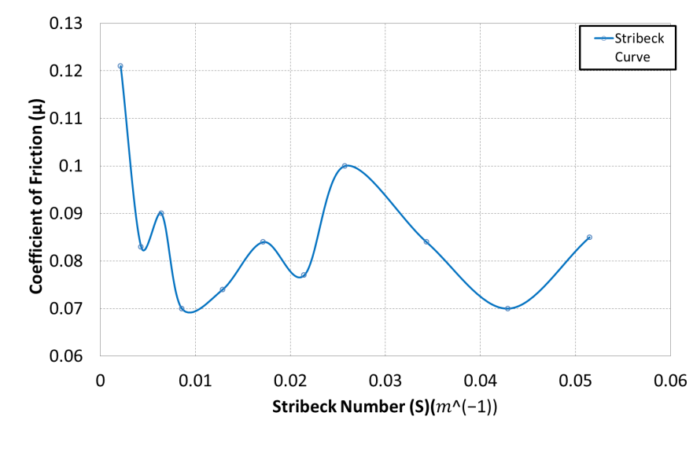

Figure 3.3-1 Stribeck Curve

Use equation 13 to calculate E’ and equation 11 to calculate R’, these values are used to calculate a, by using equation 10, which is used to calculate the average and maximum contact pressure.

Since there is no contat in the hydrodynamic lubrication regime the average oil pressure must be higher than 344MPa.

## Wear at OCP

The results for the Wear at OCP experiment are presented in figure 3.4-1

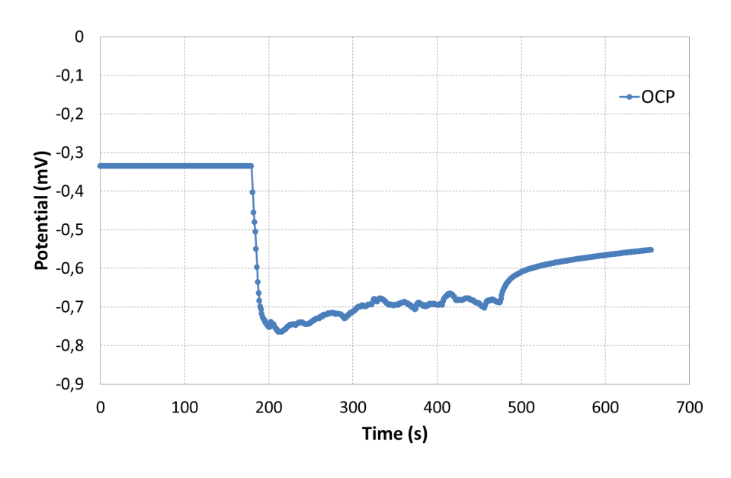

## Potentiostatic Wear

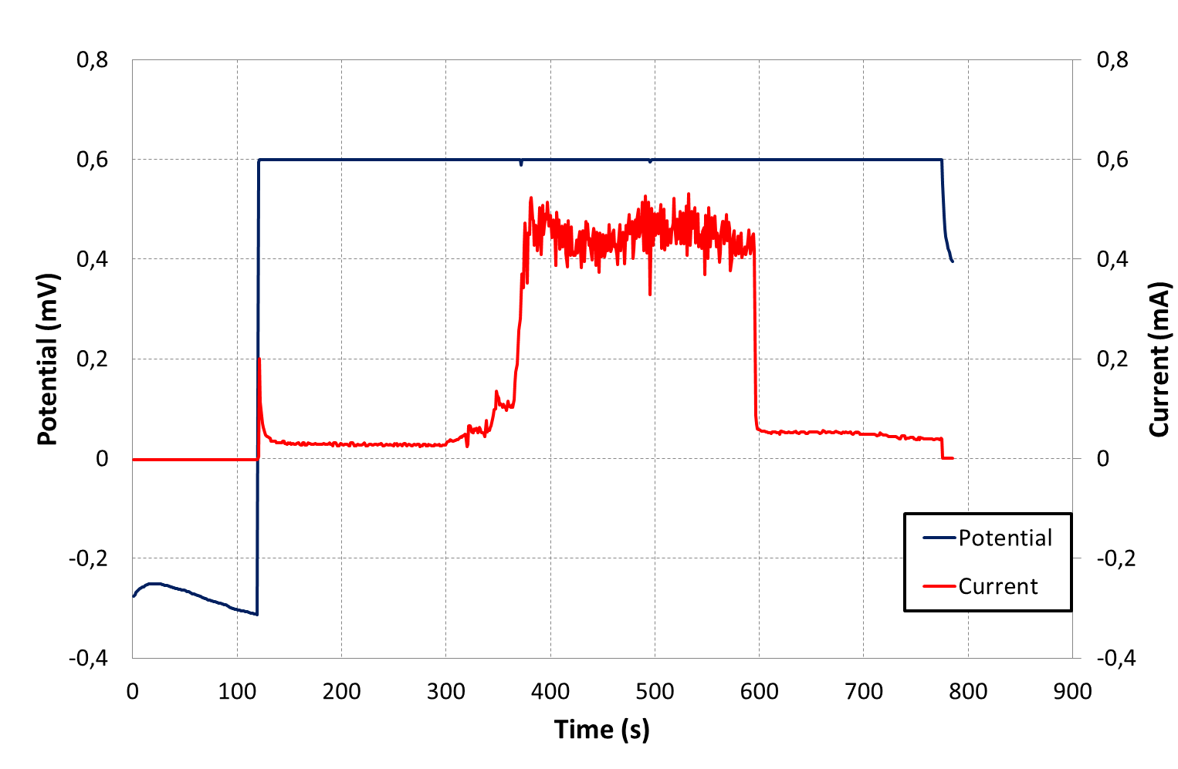

The average current between 375seconds and 575 seconds is calculated to 0,448mA, and this value is used for the corrosion rate calculations.

To calculate the thickness loss in years the same equation and values are used as for the corrosion experiments.

The corrosion rate for the duplex plate, if assumed uniform corrosion, would be 0,90mm/year. The local corrosion rate in the area subjected to wear is about 7,5mm/years.

Volume loss based on corrosion rate on entire sample:

Volume loss based on corrosion rate on wear area:

# Discussion

## Corrosion Tests

The results from the LPR and Polarization Curves are not that different, with only 0,03mm/year difference in corrosion rate.

The Polarization Curve method is more accurate than the LPR, as the polarization curves experiment has more measurements than the LPR experiments. One mistake or inaccurate measurement will cause the LPR results to be completely wrong, while this is not the case for the polarization curve.

## Tribology Test

The experiment did not yield the results that were expected. From the Stribeck curve it was impossible to clearly determine were the different regimes were. What went wrong is not easily identified. It may be one or all of several things.

The Stribeck Curve was more or less as expected until 6cm/s, after that, when the coefficient of friction started falling again, it was clear that our results didn’t match the theory, and the results was unexpected, as the theory implies that the coefficient or friction should increase further.

The pretreatment might have been done incorrectly, or not thorough enough. Something may be wrong with the machine, causing it to give wrong measurements. Too much lubrication in the system may have affected the system in a way. It is more likely than not that the results are completely wrong.

## TriboCorrosion Tests

As expected the potential fell dramatically when applying wear, due to the material losing its passive oxide layer, which is the reason for the higher potential. As expected the wear will increase the corrosion rate of the material. Before wear the corrosion current was around 0,03mA, while after applying the wear the corrosion current increased to an average of 0,448mA, more than a tenfold increase. To discuss the corrosion rate the corrosion current is used, and not the calculated rate because of an issue with calculating the corrosion current density. This issue is discussed below.

In the Potentiostatic wear experiment the area to base the current density on must be discussed. Since the Super Duplex steel is passive the corrosion rate from the steel can’t be viewed as uniform, therefore the corrosion rate from the steel not subjected to wear can be neglected. This means that the corrosion current is generated in the area of the steel that is subjected to continuously wear, which means the corrosion current density should be based on the wear area, and not the entire steel sample.

# Conclusion

## Corrosion Tests

The OCP is the corrosion potential, and was found to be -1068mV , relative to a calomel reference electrode.

The corrosion current was 0,01mA.

The corrosion rate was 0,11mm/year according the most accurate and reliable testing method, the polarization curves.

## Triblogy Test

It is impossible to identify the different regimes from the Stribeck Curves, and subsequently impossible to say anything about what speeds that separates the regimes.

## TriboCorrosion Tests

The Super Duplex samples corrosion behavior was very influenced by the wear. The corrosion potential and corrosion rate as affected by the wear. Without any wear the corrosion rate was almost zero, by when wear was applied the corrosion rate increased greatly. The sample was vulnerable to a combination of wear and corrosion.